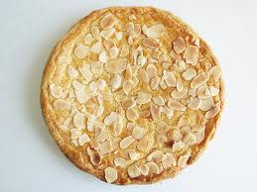
Boterkoek—a Dutch cake that is hard on the outside and soft on the inside.
1 1/3 cup butter
2 cups sugar
1 tbsp almond extract
2 eggs, beaten (reserve 2 tsp)
3 cups flour
1 tsp baking powder

Preheat oven to 350
Grease 2 pie pans.
In a mixing bowl, mix together butter, sugar and almond extract.
Add beaten eggs except for the 2 tsp
Sift together flour and baking powder. Add to bowl, and mix with butter mixture.
Put dough in greased pie pans.
Mix the reserved egg with 2 tsp water and brush over dough. Place almond slices around the edge of cake.
Bake at 350 for 25-30 minutes.
This is a dense cake that should be soft on the inside and hard on the outside.

