Crab Rangoons-These are actually more Polynesian than Chinese
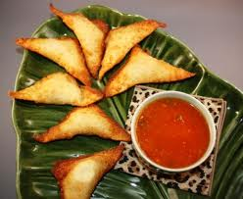
8 oz cream cheese, softened
2 (6 oz) cans crabmeat, drained and flaked
1 clove garlic minced
½ tsp soy sauce
½ tsp Worcestershire sauce
2 tbsp chopped green onion
1 pkg wonton wrappers

- Drain cans of crab meat, flake meat with a fork.
- Stir together softened cream cheese, crab, garlic, sauces and green onion.
Place wonton wrapper in front of you with a point on top.
- Place about 1 tsp filling in center of wonton wrapper.
- Moisten wrapper edges with A SMALL AMOUNT OF WATER, fold over the mixture and pinch to seal.
- Place in single layer in container and place in the freezer

Make sweet & sour sauce day 1
1/3 cup rice vinegar
4 tbsp brown sugar
1 tbsp ketchup
1 tsp soy sauce
Bring to a boil in sauce pan

- Combine 2 tsp cornstarch with 4 tsp water in custard cup until mixture is smooth.
- Stir this into hot sauce and continue whisking and cooking until thickens.
- Remove from heat and put in covered container in the refrigerator until day 2

Heat oil for deep frying and fry rangoons about 5 minutes or until brown and crisp. Serve with sauce.

