Guacamole (Mexico)

Avocado turns from green to brown quickly when exposed to air. Either serve immediately or put the pit in the middle of the mixture and then cover with plastic wrap, pressing directly onto the mixture to keep air out.

3 avocados-peeled, pitted and mashed
1 lime
1 tsp salt
½ cup finely chopped onion
3 tbsp fresh cilantro, chopped
2 roma (plum) tomatoes, diced
1 tsp minced garlic

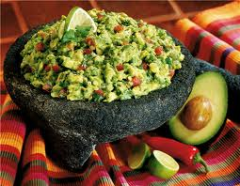
- Dice the tomato, set aside.
- Finely chop the onion, set aside
- Mince garlic, set aside
- Cut lime in half and sqeeze juice
- Cut avocado in half the long way. There is a large pit in the center. Cut to the pit and then run the knife around the avocado. Twist the two pieces in opposite directions to separate. Take a butter knife and run it under the flesh of the avocado next to the rind. Scoop it into a medium bowl.
- Mash avocado and then stir in remaining ingredients.

Serve with chips

