Food & Society

Availabilty Mrs. Gomm 986-3351 x 702 jgomm@shiocton.k12.wi.us

I am part time and work 4th-7th hours. I am often here 8th hour but do not count on it.

Materials Binder, notebook, pen/pencil

Attendance Much of the work for class is done in class. Very little homework will be given. It is important to be here every day. If you know you will be absent, make arrangements ahead of time. It is your responsibility to see me for make-up work, during my prep period or by email. You will be given time to make up the work according to the school policy.

Late Work I can’t grade assignments and count them for points if you don’t turn them in. Be sure to turn in work when it is complete in class. If work is assigned outside of class it is due by the indicated due date. Late work is not acceptable.
Students with an unexcused absence will not be able to make up work and no credit will be given for work missed.
Labs There will be labs in each unit. DO NOT EXPECT TO COOK EVERY DAY! Labs will be based on individual participation and on group clean up. Missed labs will be difficult to make up so do your best to not miss them. It may be possible to make up some labs at home. Be sure to get a form completed and signed by your parents.
Magic 4 Be respectful to classmates and teacher
Participate in classroom discussions, demonstrations and activities
Cooperate with group members
Be prepared bring your materials with you every day.

Clean up Everyone is required to participate in classroom clean up throughout the semester.
Those not participating will lose points.

Classroom Expectations:
- Attend to your personal needs before coming to class.
- Sit in your assigned seat. I can change as needed
- Be responsible for your own work.
- Bring your materials to class every day!
- Remember your manners. No sitting on the table/counters, swearing, belching, farting or feet on the table.
- No iPod, cell phones, headphones or other electronics are allowed in class unless OK’d by me.
- Maintain proper hygiene and appearance. Clean hair and fingernails are essential in foods lab.
- Stay by your tables in the classroom until the bell rings.

Topics we’ll cover:

The Role of Food
Why we eat? Where does our food come from? What attitudes do we have about food? Lab procedures, Food Storage & Preservation: Pizza Wars

Kitchen Management
Safety & Sanitation, measuring, culinary terminology,h equipment and appliances: Soups

Kitchen Math
Adjusting amounts, cost comparison, unit pricing, homemade vs convenience: Casseroles
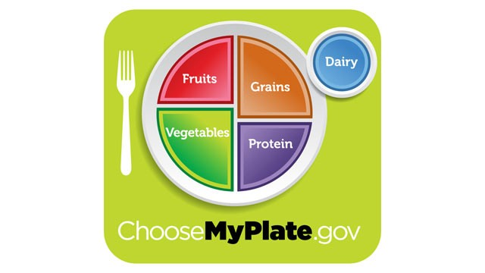

Nutrition Principles
Nutrients, Labels, My Plate, : Breakfast

Healthy Eating Habits
Functions of ingredients, How do cooking methods affect nutrition, Modifying recipes and menus, Fast food, Sports Nutrition: Sandwiches? Muffins?

Balancing Food and Fitness
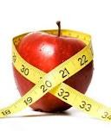
Physical Activity, Fad Diets and Eating Disorders: Salads? Smoothies?

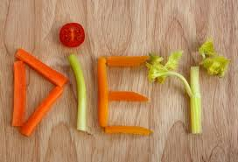

Research Project?

